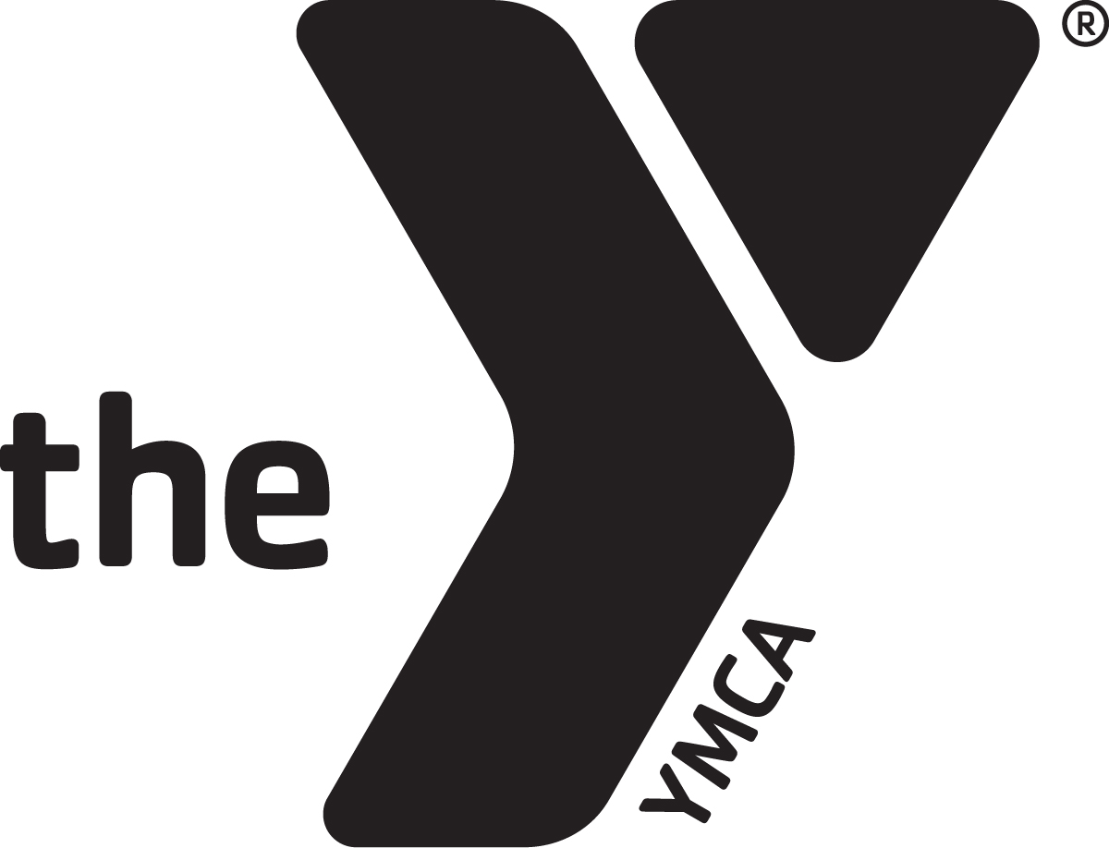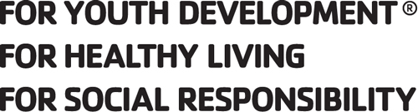
BILLINGS FAMILY YMCA JOB DESCRIPTION
Job Title: Membership Representative
FLSA Status: Part Time, Non-Exempt Revision Date: July 2019
Reports to: Membership Director and Membership Coordinator

POSITION SUMMARY: Delivers excellent service to all members, guests, and program participants. Responds to member and guest needs, promotes memberships and programs, and maintains cleanliness and organization of the lobby area.
ESSENTIAL FUNCTIONS:
- Provides excellent service to members, guests, and program participants in the Y and on the phone, contributing to member retention.
- Provide membership interviews and facility tours as needed, explaining the YMCA mission, volunteer opportunities, the Annual Campaign and Financial Assistance. Ask prospective members to join and make follow up contact with those who did not sign-up.
- Handles and resolves membership concerns in a courteous manner and informs supervisor of unusual situations or unresolved issues.
- Process new member ID cards, issue guest passes and register members for programs and services, as needed.
- Follow proper procedures for group memberships, AWAY members, and guests who come in to use the facility. Follow identification requirements and guest guidelines verifying all documentation to ensure visitors and members are not listed on the Montana State Sexual and Violent Offender registry.
- Schedule court reservations, provide rental equipment and sell YMCA merchandise. Maintain an accurate inventory and record of daily transactions.
- Responsible for balance and close out of their individual sales at the end of each shift, placing cash bags with close out in the safe.

CORE COMPETENCIES (ALL STAFF):
CUSTOMER SERVICE
- Always have a friendly, helpful attitude and wear a smile.
- Take initiative to greet and assist all members, potential members, program participants and volunteers in a courteous, professional and friendly manner. Be enthusiastic towards members by learning their names and expressing an interest in their YMCA activities.
- Work daily to develop personal and meaningful relationships with members, volunteers, donors and others. Strive to understand individual’s goals and interests to enrich their YMCA experience by introducing them to new programs, staff, members and volunteer activities.
- Actively listen, reflect and respond to member questions and concerns in a caring manner. When the opportunity presents itself, go above and beyond to resolve the situation immediately.
- Embrace new approaches and discover ideas to create a better member experience.
MISSION ADVANCEMENT
- A willingness to commit to the mission of the YMCA. Demonstrate a desire to serve others and fulfill community needs.
- Is familiar with and able to articulate the mission statement, areas of focus and core values of the YMCA with people of all ages and backgrounds. Models the core values of caring, honesty, respect and responsibility while working and communicating with members, program participants, volunteers and other staff members.
- Be knowledgeable and supportive of the YMCA annual support campaign.
- Be informed about volunteer opportunities.
- Speak enthusiastically on behalf of the YMCA publicly and at given opportunities.
TEAMWORK
- Ability to establish and maintain harmonious relationships with staff members in all departments.
- Seeks every opportunity to encourage, motivate and thank fellow staff members for their work. Completes S.T.A.R. slips to thank and recognize a job well done by others.
- Be knowledgeable about YMCA programs. This includes being familiar with all current program guide information, upcoming events and other special activities.
- Keeps up to date all internal communication.

OPERATIONAL EFFECTIVENESS/SAFETY
- Be dressed in appropriate attire and wear nametag at all times. Consistently perform duties in a safe and conscientious manner.
- Follow and enforce all YMCA procedures and policies, including those related to: personnel guidelines, medical and disciplinary situations, child abuse prevention, safety guidelines, facility access procedures, membership policies and emergencies. Complete Incident Report Forms as required.
- Be knowledgeable of all current Emergency Action Plans and carry out plans as necessary.
- Maintain a clean and safe YMCA. Take initiative to clean up/repair areas. Complete Maintenance Request forms as needed. Report safety issues to the appropriate supervisor.
- Attend and remain current on all mandatory trainings and staff meetings.

QUALIFICATIONS:
- Certifications required within 30 days of hire: CPR/AED, and First Aid.
- Excellent interpersonal and problem solving skills.
- Ability to relate effectively to diverse groups of people from all social and economic
segments of the community.
- Previous customer service, sales or related experience.
- Good computer skills, data entry experience preferred.

PHYSICAL DEMANDS:
- Must be in reasonable good physical condition and be able to work extended periods of time on his/her feet.
- Ability to perform all physical aspect of the position; including walking, standing, bending, kneeling, and lifting.
- The physical ability to take potential members and guests on tours throughout the entire facility.
- Visual and auditory ability to respond to critical situations and physical ability to act swiftly in an emergency.

This job description may not be all inclusive and employees are expected to perform all other duties as assigned and directed by management. Job descriptions and duties may be modified when deemed appropriate by management.
Employee Name:
Employee Signature: Date:
Directors Signature: Date:

