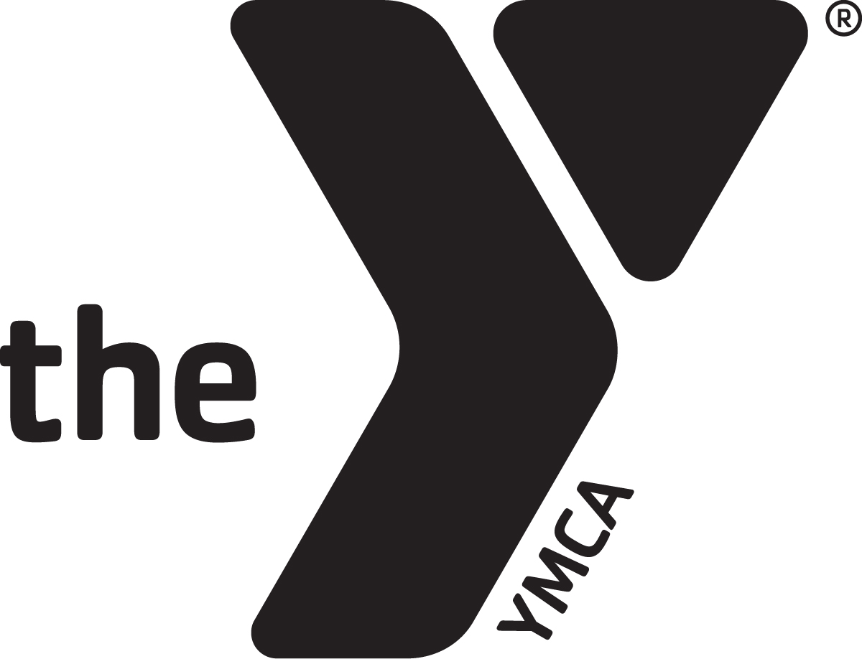
BILLINGS FAMILY YMCA JOB DESCRIPTION
Job Title: Water Exercise Instructor
FLSA Status: Part-time, Non-Exempt Revision Date: 10/19/2023
Reports to: Aquatics Director

POSITION SUMMARY:
Provides direct leadership, instruction and motivation for people in water fitness classes.

ESSENTIAL FUNCTIONS:
- Instructs water exercise classes as assigned in accordance with YMCA guidelines, having prepared lesson plans accordingly.
- Encourages member involvement and identifies potential volunteers.
- Conveys information on aquatics programs and schedules and as appropriate refers members and participants to other programs.
- Maintains records as required.
- Organizes and puts away needed class equipment. Reports damaged equipment to supervisor.
- Trains and supervises class aides as assigned.

CORE COMPETENCIES (ALL STAFF):
CUSTOMER SERVICE
- Always have a friendly, helpful attitude and wear a smile.
- Take initiative to greet and assist all members, potential members, program participants and volunteers in a courteous, professional and friendly manner. Be enthusiastic towards members by learning their names and expressing an interest in their YMCA activities.
- Work daily to develop personal and meaningful relationships with members, volunteers, donors and others. Strive to understand individual’s goals and interests to enrich their YMCA experience by introducing them to new programs, staff, members and volunteer activities.
- Actively listen, reflect and respond to member questions and concerns in a caring manner. When the opportunity presents itself, go above and beyond to resolve the situation immediately.
- Embrace new approaches and discover ideas to create a better member experience.
MISSION ADVANCEMENT
- A willingness to commit to the mission of the YMCA. Demonstrate a desire to serve others and fulfill community needs.
- Is familiar with and able to articulate the mission statement, areas of focus and core values of the YMCA with people of all ages and backgrounds. Models the core values of caring, honesty, respect and responsibility while working and communicating with members, program participants, volunteers and other staff members.
- Be knowledgeable and supportive of the YMCA annual support campaign.
- Be informed about volunteer opportunities.
- Speak enthusiastically on behalf of the YMCA publicly and at given opportunities.
TEAMWORK
- Ability to establish and maintain harmonious relationships with staff members in all departments.
- Seeks every opportunity to encourage, motivate and thank fellow staff members for their work. Completes S.T.A.R. slips to thank and recognize a job well done by others.
- Be knowledgeable about YMCA programs. This includes being familiar with all current program guide information, upcoming events and other special activities.
- Keeps up to date all internal communication.

OPERATIONAL EFFECTIVENESS/SAFETY
- Be dressed in appropriate attire and wear nametag at all times. Consistently perform duties in a safe and conscientious manner.
- Follow and enforce all YMCA procedures and policies, including those related to: personnel guidelines, medical and disciplinary situations, child abuse prevention, safety guidelines, facility access procedures, membership policies and emergencies. Complete Incident Report Forms as required.
- Be knowledgeable of all current Emergency Action Plans and carry out plans as necessary.
- Maintain a clean and safe YMCA. Take initiative to clean up/repair areas. Complete Maintenance Request forms as needed. Report safety issues to the appropriate supervisor.
- Attend and remain current on all mandatory trainings and staff meetings.

QUALIFICATIONS:
- Certifications: CPR for the Professional Rescuer, AED, Basic First Aid certification.
- Must be able to demonstrate swim instructor skills in accordance with YMCA standards.
- At least 16 years of age.

PHYSICAL DEMANDS:
- Ability to instruct and observe participants in proper exercise techniques.
- Ability to lift equipment, and to lift a small to average size child.
This job description may not be all inclusive and employees are expected to perform all other duties as assigned and directed by management. Job descriptions and duties may be modified when deemed appropriate by management.
Employee Name:
Employee Signature: Date:
Directors Signature: Date:

