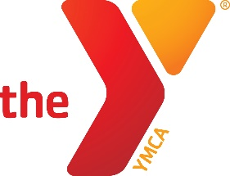
Tiny Tots Sports Basketball Coach
Position Type: Part-time
Salary Range: $15.00
Scheduled Hours: Evenings
Core Job Responsibility: Tiny Tots sports specialist is responsible for maintaining a positive and safe sporting environment. Be willing to coach sports. Be able to coach in front of parents, while bringing the parents in to help. Officiate sports fairly and positively. Promote programming that the YMCA offers and represent the YMCA’s core values.
Who Should Apply: You should apply to this position if you love sports and helping youth. Some experience in coaching sports is preferred but not required. We will train anyone who wants to help youth. Must have a positive attitude, and a drive to help kids.
The Youth Sports Specialist will be required to:
- Coach Sports according to YMCA rules.
- Provide a safe and clean environment for children.
- Report to the Sports Director on all incidents of significance.
- Be willing to address parents to get them to help with practice.
- Be respectful and professional to participants and fellow staff.
- Be able and willing to coach or help coach teams as needed.
- Additional assigned tasks.

